We Ship To 39 States: 
- Alabama
- Arkansas
- Arizona
- California
- Colorado
- District of Columbia
- Florida
- Georgia
- Iowa
- Idaho
- Illinois
- Indiana
- Kansas
- Louisiana
- Massachusetts
- Maryland
- Maine
- MICHIGAN
- Minnesota
- Missouri
- North Carolina
- North Dakota
- Nebraska
- Nevada
- New Hampshire
- New Mexico
- New York
- Ohio
- Oregon
- Pennsylvania
- South Carolina
- Tennessee
- Texas
- Virginia
- Vermont
- Washington
- Wisconsin
- West Virginia
- Wyoming

Thank You For Your Patronage!
Susan & Bill Braymer


/2022 

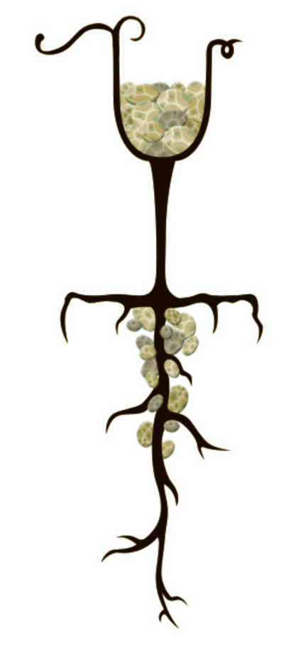



 

2022 BENEFITS:
- 25% Bonus Signup Day Discount!
- 20% Member Discount after if active!
- Visiting members receive
  - 1 glass of wine complimentary per visit OR
  - 1 featured club wine flight during April/October, club release months
  - Note: Glass/Flight tasting subject to COVID policy restrictions
- Full month club release pickup celebration during April/October open to all members
- *If desired, piggyback (add) any 6 bottles to club wines to qualify for complimentary 12 bottle shipping by written confirmed requests received before end of April or October
- Priority for large bottle (magnum) orders
- Active member discount for regular price online orders
- Annual Library sales the entire month of August
- Access to pre-releases prior to public release
- Newsletter updates

HOW LLWC WORKS:
- We choose pre-release wines to expand your palate both spring/fall
- You choose quantity: 12/ 6 bottles Note 6 bottles must be club wines. 12 bottles may be ALL club wines or 6 club wine plus ANY additional bottles
- Signup bonus discount and member discounts apply to regular price retail and wine bottles
- Reminder emails sent the month before the pre-release
- Special shipping rates are for the 12 and 6 packs for the club releases only. Refunds on return shipments will subtract actual shipping cost
- All wine not picked up during release months shipped the following month(s)
- Please read and initial: To be

an active member, I agree to 2 wine pre-releases per year scheduled during spring/fall
- Circle quantity: I have agreed to 12 or 6 bottle club pre-releases 2 times per year

Please Fill In Completely
Circle Number of Bottles:
12 or 6

Circle Ship or Pickup Preference: 
Ship or Pickup
Pickup ALL April or October
12 pack shipping Complimentary*
6 pack shipping $22

Circle Wine Preference:
1.No Preference Mix
2. Dry Only
3. Sweet Only

Please Print
Name:

Email:

Phone:

Shipping: No PO Box

Billing: Need zip code

Credit Card:

CVV: Expiration: /

Date of Birth:
/ /

Driver’s License:

Customer Signature:

------------------------------------------------------------------------------------------------------------

Staff Signature:__________________________________
Date:___________________________________________

